School Community Council Meeting Minutes
Sprucewood Elementary
October 26, 2020

Members Present:
Faculty | Community
Cathy Schino (Principal) | Mindy Cupello
Cindy Bronson (Teacher) | Jason Dyer (Vice Chair)
Isaiah Folau (Teacher) | Caitie Ely (Chair)
 | Alison Holbrook
 | Bo Jensen
 | Brooke Mathews

Members Absent: Emily Jensen, Tricia Leininger

AGENDA
- Call Meeting to Order
  - 4:03
- Review and approve last month’s meeting minutes
  - J. Dyer motion to approve minutes, motion seconded
    - Unanimously affirmed
- School Climate Goal proposed change (due to COVID-19 needs)
  - Sprucewood’s Building Leadership Team (BLT) met on October 14th and decided to change our School Climate goal away from focusing on attendance initiatives (due to COVID precautions we do not want to encourage students to come to school if at all sick) to focusing on using Morning Meetings to help students adjust from home life to school life each morning.
    - Components: Greeting, Sharing, Group Activity and Message
    - Time: 8:50-9:10am daily
    - Benefits:
      - Greeting= acknowledge the presence of themselves and others, become more comfortable in social situations, gain a sense of community and belonging, gain self-esteem, make eye contact, wait turn, welcome classmates to the group, pay attention and focus on the speaker
      - Sharing= develop communication skills in expressive and receptive language, develop leadership skills, retell experiences in sequence, use critical thinking skills, organize ideas, select appropriate thoughts to share, ask respectful questions and give meaningful comments, express opinions, pay compliments
      - Group Activity= solve problems, think quickly and creatively, play and follow simple rules, use language creatively, interact easily with classmates, learn through movement, support each other, have fun together
      - Message= participate in oral reading, recall familiar words, read accurately and with expression, follow directions, work independently, use grammar properly

    - Goal: By May 2021 100% of Sprucewood home-room teachers will be implementing all four components of Morning Meeting daily between 8:50-9:10am.
  - M. Cupello asked if guidance could be provided to conduct a morning meeting at home on Fridays where school isn’t in session
    - C. Bronson and I. Folau commented as to a component (message) that could be shared as part of the work that is sent home
    - C. Schino voiced taking the question to teachers to the next BLT meeting and will revisit the request on November 30th
  - A. Holbrook asked what other things the school climate goal could have been centered around (Second Step, Class Dojo)
    - C. Schino noted that the other things are still being implemented but they aren’t going to be the focus of the climate goal
  - SCC vote to approve goal was unanimous

- LANDtrust and TSSP budget proposed changes (due to COVID-19 needs)
  - Sprucewood’s Building Leadership Team (BLT) met on October 14th and voted unanimously to use LANDtrust funds to pay for salaries of MTSS aides and technology. They voted unanimously to use TSSP funds for technology.
    - 95% group intervention materials discussion: the original idea to purchase 95% group for classroom teachers to use for intervention instruction during SBI time was made last year with the understanding that our MTSS aides would transition to a push in model. This would allow our teachers to instruct our lowest readers, while our aides instructed groups of students at or above benchmark. This is not a possibility this year due to COVID 19 safety plans. It is safest to keep students in their classrooms and only pull out students who are below benchmark into a small group setting.
    - Principal Schino found an acceptable option she felt was a great compromise. Instead of purchasing additional 95% Intervention Program materials, the 95% Core Program could be used by K-3rd grade teachers during Core instruction time (foundations minutes in master schedule). She was willing to purchase using school textbook funds, but was denied at district level. She was informed the 95% Core Program is new and the Instructional Supports Department (ISD) hasn’t approved it yet. Sprucewood can be a pilot school in the future if ISD adds the 95% Core program to the approved district list.
      - So now the proposed options are to either 1) purchase 95% intervention program for next year if COVID 19 precautions can be decreased and MTSS aides can safely teach in every classroom with low risk, or 2) purchase 95%Core Program with possible future district approval
  - Tech Purchase updating Chromebooks
    - Motion to approve using LAND Trust and TSSP funds for tech purchases
      - A. Holbrook motioned to approve, motion seconded
        - Motion was approved unanimously

- School Safety Discussion- Please read the school safety report information on our district website SCC page (https://www.canyonsdistrict.org/safe-schools/) prior to our next meeting November 30th. Come with questions and ideas to help complete the following...
  - Who, besides the SCC members, participated (did you invite the SRO, school counselor, psychologist or district personnel?)
  - Did you feel the information presented in the District School Community Council School Safety Report was helpful?
  - What, if any, school safety items did your SCC discuss that were not in the report?
  - Your SCC has been asked to determine the #1 safety concern at your school after reading the report and discuss-ing safety topics at your school. What has your SCC determined to be the #1 safety concern for your school?
  - What additional items did you identify as primary concerns, if any?
  - Does your SCC have an action plan to help address the concerns?

- Digital Citizenship Discussion
District Filtering & Systems
    - We invited Scot McCombs, Canyons’ Director of Informational Technology to discuss filtering and Sara Lee, Sprucewood’s Digital Citizenship Coordinator to discuss efforts and communication regarding digital citizenship
    - **the council decided to sit on these questions for a month and review the school safety plan, they decided to return to the discussion on Nov. 30th
- Does the SCC feel it has received enough information to determine if the filtering systems and supervision practices are appropriate?

- Does the SCC feel it has received enough information about the school’s educational efforts to instill in students a desire to be good digital citizens?

- Does the SCC believe the school has a viable plan to present important Internet Safety and Digital Citizenship information to parents in the community?
    - Parent Education: Enter the date of your first community outreach: ____________________________
  - Enter a short description of your first community outreach activity/opportunity:
    - Enter the date of your second community outreach:__________________________________________
  - Enter a short description of your second community outreach activity/opportunity:

- Cell Phone Tower
  - C. Schino voiced an update to the tower
    - The cell tower is still operational and as such, the school will still receive funds for its being on the property
    - Since the merger of Sprint and T-Mobile, the discussion has faded however, the district is still in contact with them though we don’t have a timeline for when T-Mobile will return to the discussion about using, removing, or moving the tower as it is updated.
    - Whatever and whenever updates to the discussion do happen, they will go through the SCC
  - As a review:
    - The council did agree to have the tower moved to the southwest corner of the school (ideally) or to have it remain in its place, though the council was not aware of what the upgrade to the tower would comprise and so expects to revisit the discussion
  - A. Holbrook voiced reservations as to what the update of the tower to 5G means for safety.
    - C. Schino provided two websites that addressed some of the health concerns for review.
      - https://howmobileworks.com/
        - The tabs at the top of page that say public safety & health and FAQs & Resources have information that should answer the questions you have regarding safety of towers.
      - https://www.wirelesshealthfacts.com/
  - The council agreed to remain in a “holding pattern” of sorts until word from T-Mobile and what they expect and want to do with the tower is returned to.

- School Data
  - Reading Data- Our reading goal states we will move 60% of students from below or well below benchmark to at or above benchmark by May 2021.
    - K= move 14/22 (if successful 85% of grade on benchmark)
    - 1st= move 13/21(if successful 84% of grade on benchmark)
    - 2nd= move 10/16 (if successful 88% of grade on benchmark)
    - 3rd= move 9/15 (if successful 87% of grade on benchmark)
    - 4th= move 8/13 (if successful 88% of grade on benchmark)
    - 5th= move 15/24 (if successful 84% of grade on benchmark)
  - 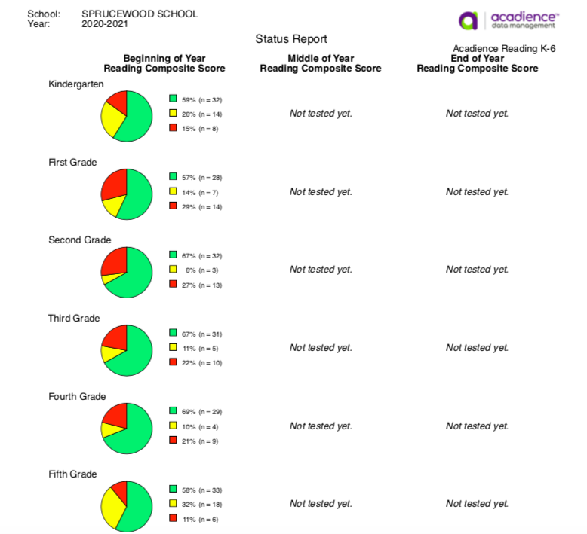

- Adjourn until next month’s meeting November 30, 2020
  - C. Ely adjourned meeting at 5:13

