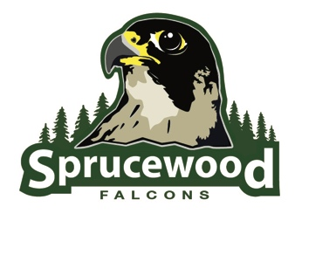
Sprucewood Elementary
School Community Council Meeting Minutes
November 11th, 2019

Members Present:
Faculty | Community
Lori Reynolds (Principal) | Jason Dyer (Chair)
Cindy Bronson (Teacher) | Alison Holbrook
Isaiah Folau (Teacher) | Tess Hortin
 | Jenni Morgan (Vice Chair)
Minutes:
- J. Dyer called meeting to order at 4:09
- Approval of September Minutes
  - L. Reynolds noted and showed where the SCC meeting minutes were posted on the website
  - L. Reynolds motioned to approve the September minutes, vote was unanimous in the affirmative
- Digital Citizenship Updates
  - K. Willie (teacher and faculty digital citizenship lead) came into the meeting to explain what resources, activities, and lessons will be utilized by teachers for the upcoming Digital Citizenship Week (11/18-22)
  - A. Holbrook asked if the digital citizenship posters could be rotated through the PTA newsletters on the back.
    - L. Reynolds agreed and stated that it wouldn’t be hard to put on the back
    - J. Morgan asked if the newsletters could be sent out digitally
      - L. Reynolds said that it could and that is something to look forward to
  - The lessons run for about 20 minutes, are grade appropriate, and teachers will cover two of them for the week
  - C. Bronson mentioned that the effort would be more impactful if the lessons started earlier and ran continually
- Land Trust Final Report
  - L. Reynolds presented the final reports
  - J. Dyer, C. Bronson, A. Holbrook, and L. Reynolds discussed the projected versus actual funds received and how to read the data table
  - L. Reynolds explained to the council the CSIP goal from the 2018/19 and what performance was achieved
  - L. Reynolds will send out the final reading inventory measures.
  - A. Holbrook asked L. Reynolds how she feels and thinks about the measures achieved.
    - L. Reynolds responded that the state sets the goal and that improvement can always be had, particularly in the portion of the goal that doesn’t show the growth expected
    - Professional development is being had among the K, 1, 2 grades that is focused on foundational concepts that work towards the goal
    - I. Folau spoke to the professional development that the 2nd grade is receiving that is aligned towards the goal.
    - A. Holbrook raised a question surrounding programs, platforms, and names and of how frequently they seem to change and if more clarity surrounding their continuity and purpose could be provided.
- Cell Tower Funds
  - L. Reynolds shared that there are $18,145.32 in the fund. There are no updates on the design
  - L. Reynolds wants to put on another holiday party and is seeking the approval of the council to use some of the Cell Tower funds for the event. All agreed that it would be okay
- School Safety Report and Input
  - J. Morgan noted that in terms of safety, substitutes need also to be made aware of the procedure and potentially provided a binder or information sheet to make them aware of what to do in the event of a real emergency or drill
    - L. Reynolds agreed and said that a quick information sheet could be drawn up and provided
  - J. Dyer noted that in terms of emergency contact, a text rather than a phone call would be preferred as it doesn’t get lost to voicemail and remains a notification that must be cleared
  - Council agreed to continue discussion of agenda item #7 until December
  - All agreed to hold a December meeting
- Meeting adjourned at 5:15 to reconvene on 12/9/19

